

**Course Instructor: Muhammad Anas**

**GROUP MEMBERS**

* **AREEBA ABDUL RAZZAQ 23163**
* **SHARMEEN ZUBAIR 22509**
* **LAREB RAZZAQ 22635**

[DIGITAL IMAGE PROCESSING LAB]

### *Project Name: Image Processing Tool Using Stream-lit and Open-CV*

### 1. ****Introduction****

The advent of digital technology has enhanced the capabilities of image processing, making it an essential field in computer vision, graphic design, and various industrial applications. This report discusses an Image Processing Tool, developed using Python libraries such as Open-CV, NumPy, Stream-lit, and PIL. The tool allows users to perform a wide range of operations on images, such as background removal, edge detection, blurring, re-sizing, rotation, and image addition.

### 2. ****Problem Statement****

In real life, we encounter several challenges related to image manipulation:

* **Background Distractions**: Unwanted backgrounds in images reduce their clarity and utility.
* **Edge Identification**: Detecting the boundaries of objects in an image is difficult without automation.
* **Image Quality Issues**: Images may need to be blurred for artistic purposes or to reduce noise.
* **Re-sizing Constraints**: Images must often be re-sized for compatibility with specific devices or platforms.
* **Alignment Challenges**: Rotating images to desired orientations can be complex without precise tools.
* **Composite Image Creation**: Merging multiple images seamlessly requires specialized software.

### 3. ****Project Objective****

The objectives of the project are:

* To provide an easy-to-use tool for performing common image processing tasks.
* To enable users to:
* Remove unwanted backgrounds from images.
* Detect edges for object identification.
* Apply blurring for aesthetic and technical purposes.
* Resize images to desired dimensions.
* Rotate images to correct alignment or for artistic effects.
* Add or blend multiple images to create composites.

### 4. ****Scope of the Project****

This tool is designed for:

* Individuals working in photography, graphic design, or content creation.
* Developers needing an efficient solution for preprocessing images in machine learning or computer vision applications.
* Educators and students in digital image processing courses.
* Casual users interested in enhancing their images for personal use.

### 5. ****Methodology****

The tool is built using the following technologies and methods:

1. **Python Libraries**:

* **Open-CV**: For core image processing operations.
* **NumPy**: For handling multidimensional arrays and matrices.
* **PIL (Pillow)**: For advanced image manipulation.
* **Stream-lit**: For creating an intuitive web-based interface.

1. **User Interface**:

* A sidebar allows users to select desired operations.
* Sliders and buttons facilitate customization (e.g., rotation angles, blur scales).

1. **Operations**:

* **Background Removal**: Uses thresholding and morphological operations to isolate the subject.
* **Edge Detection**: Applies the Canny edge detection algorithm.
* **Blurring**: Implements Gaussian blurring with user-defined parameters.
* **Re-sizing**: Re-sizes images to specified dimensions.
* **Rotation**: Rotates images using affine transformation matrices.
* **Image Addition**: Blends two images using weighted sums.

1. **Deployment**:

* Hosted as a web application using the Stream-lit framework.
* Allows image uploads, previews, and downloads.

### Code

import cv2  # OpenCV library for image processing

import numpy as np  # for arrays and matrices

import streamlit as st  # Streamlit library for building web apps

from PIL import Image  # Pfor imagemanipulation

import io  # Input/Output library for handling binary streams

# Streamlit app setup

st.title("Image Processing Tool")  # Set the title of the Streamlit app

# Sidebar for user navigation

st.sidebar.header("Operations")  # Add a header in the sidebar for clarity

# Create a multiselect widget in the sidebar for selecting operations to apply

operations = st.sidebar.multiselect("Select operations to apply", [

    "Background Removal",

    "Edge Detection",

    "Image Blurring",

    "Image Resizing",

    "Image Rotation",

    "Image Addition"

])

# Function to upload an image

def upload_image(key=None):

    # Allow user to upload an image with specified file types

    uploaded_file = st.file_uploader("Upload an image", type=["jpg", "png", "bmp", "jpeg"], key=key)

    if uploaded_file is not None:  # Check if an image was uploaded

        # Open the uploaded image and convert it to RGBA format

        image = Image.open(uploaded_file).convert("RGBA")

        return np.array(image), image  # Return both NumPy array and PIL image

    return None, None  # Return None if no image is uploaded

# Function to enable image download

def download_image(image):

    buffer = io.BytesIO()  # Create an in-memory binary stream

    image.save(buffer, format="PNG")  # Save the image to the stream in PNG format

    st.download_button(

        label="Download Processed Image",  # Button label

        data=buffer.getvalue(),  # Binary data of the image

        file_name="processed_image.png",  # Default file name for download

        mime="image/png"  # MIME type for the download

    )

# Function to remove the background from an image

def remove_background(image):

    if image.shape[2] == 4:  # Check if the image has an alpha channel (RGBA)

        b, g, r, a = cv2.split(image)  # Split into individual channels

        rgb_image = cv2.merge((b, g, r))  # Merge RGB channels (discard alpha temporarily)

    else:  # If the image has no alpha channel (RGB)

        rgb_image = image

    gray = cv2.cvtColor(rgb_image, cv2.COLOR_BGR2GRAY)  # Convert to grayscale

    # Apply binary thresholding with Otsu's method to create a mask

    _, mask = cv2.threshold(gray, 0, 255, cv2.THRESH_BINARY_INV + cv2.THRESH_OTSU)

    kernel = np.ones((5, 5), np.uint8)  # Create a morphological kernel

    mask = cv2.morphologyEx(mask, cv2.MORPH_CLOSE, kernel)  # Close small holes in the mask

    b, g, r = cv2.split(rgb_image)  # Split RGB channels again

    result = cv2.merge((b, g, r, mask))  # Add the mask as an alpha channel

    return result  # Return the image with the background removed

# Function to detect edges in an image

def detect_edges(image):

    return cv2.Canny(image, 100, 200)  # Apply Canny edge detection with thresholds

# Function to blur an image

def blur_image(image, blur_scale):

    # Ensure the blur scale is greater than 1 and an odd number

    if blur_scale <= 1:

        blur_scale = 3  # Set to minimum acceptable value

    if blur_scale % 2 == 0:

        blur_scale += 1  # Make odd if it's even

    kernel_size = (blur_scale, blur_scale)  # Define kernel size for blurring

    return cv2.GaussianBlur(image, kernel_size, 0)  # Apply Gaussian blur

# Function to resize an image

def resize_image(image, width, height):

    return cv2.resize(image, (width, height))  # Resize to the specified dimensions

# Function to rotate an image

def rotate_image(image, angle):

    (h, w) = image.shape[:2]  # Get height and width of the image

    center = (w // 2, h // 2)  # Define the center of rotation

    matrix = cv2.getRotationMatrix2D(center, angle, 1.0)  # Compute rotation matrix

    return cv2.warpAffine(image, matrix, (w, h))  # Apply rotation using the matrix

# Function to add two images

def add_images(image1, image2):

    # Convert grayscale images to RGBA if needed

    if len(image1.shape) == 2:

        image1 = cv2.cvtColor(image1, cv2.COLOR_GRAY2BGRA)

    if len(image2.shape) == 2:

        image2 = cv2.cvtColor(image2, cv2.COLOR_GRAY2BGRA)

    # Resize second image to match dimensions of the first

    if image1.shape[:2] != image2.shape[:2]:

        image2 = cv2.resize(image2, (image1.shape[1], image1.shape[0]))

    # Ensure both images have the same number of channels

    if image1.shape[2] != image2.shape[2]:

        if image1.shape[2] == 4:

            image2 = cv2.cvtColor(image2, cv2.COLOR_RGB2BGRA)

        else:

            image1 = cv2.cvtColor(image1, cv2.COLOR_BGRA2BGR)

    # Blend the two images with equal weights

    return cv2.addWeighted(image1, 0.5, image2, 0.5, 0)

# Main application logic

st.write("Please upload an image.")  # Prompt the user to upload an image

image, pil_image = upload_image(key="main_image")  # Upload image with a unique key

if image is not None:

    st.image(pil_image, caption="Uploaded Image")  # Display the uploaded image

    # Convert RGBA to BGRA for OpenCV processing

    result = cv2.cvtColor(image, cv2.COLOR_RGBA2BGRA)

    for operation in operations:  # Iterate over selected operations

        if operation == "Background Removal":

            result = remove_background(result)

        elif operation == "Edge Detection":

            result = detect_edges(result)

        elif operation == "Image Blurring":

            # Allow user to adjust blur scale via sidebar slider

            blur_scale = st.sidebar.slider("Blur Scale", 1, 50, 15, step=2)

            result = blur_image(result, blur_scale)

        elif operation == "Image Resizing":

            # Allow user to adjust width and height via sliders

            width = st.sidebar.slider("Width", 10, 1000, result.shape[1])

            height = st.sidebar.slider("Height", 10, 1000, result.shape[0])

            result = resize_image(result, width, height)

        elif operation == "Image Rotation":

            # Allow user to set rotation angle via slider

            angle = st.sidebar.slider("Angle", -180, 180, 0)

            result = rotate_image(result, angle)

        elif operation == "Image Addition":

            st.write("Upload another image for addition:")  # Prompt for another image

            add_image, add_pil_image = upload_image(key="add_image")

            if add_image is not None:

                result = add_images(result, add_image)

            else:

                st.warning("Please upload another image to perform addition.")

    # Convert BGRA to RGBA for display

    result_rgb = cv2.cvtColor(result, cv2.COLOR_BGRA2RGBA)

    st.image(result_rgb, caption="Processed Image", channels="RGBA")  # Display the result

    # Convert back to PIL format for downloading

    result_pil = Image.fromarray(result_rgb)

    download_image(result_pil)  # Provide download option

st.sidebar.info("Made with Streamlit and OpenCV")  # Add footer in sidebar

if __name__ == "__main__":

    st.write("Run this script using the Streamlit CLI.")  # Instruction for running the script

### Code snapshots

* **Image Addition:**

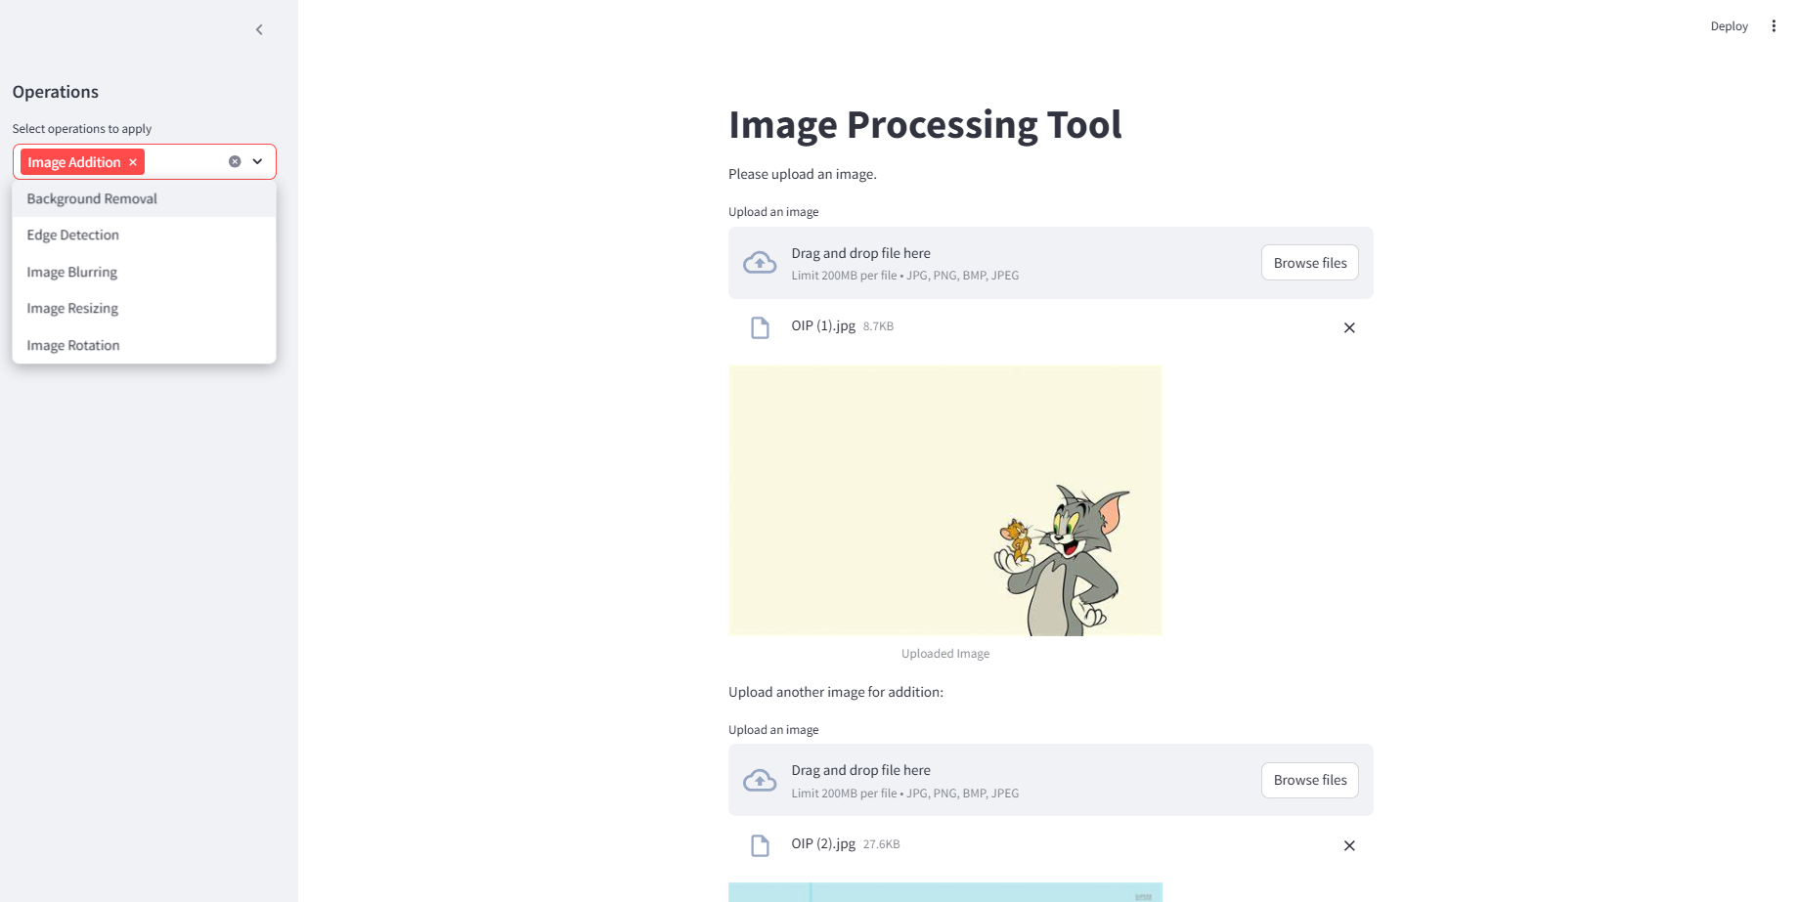

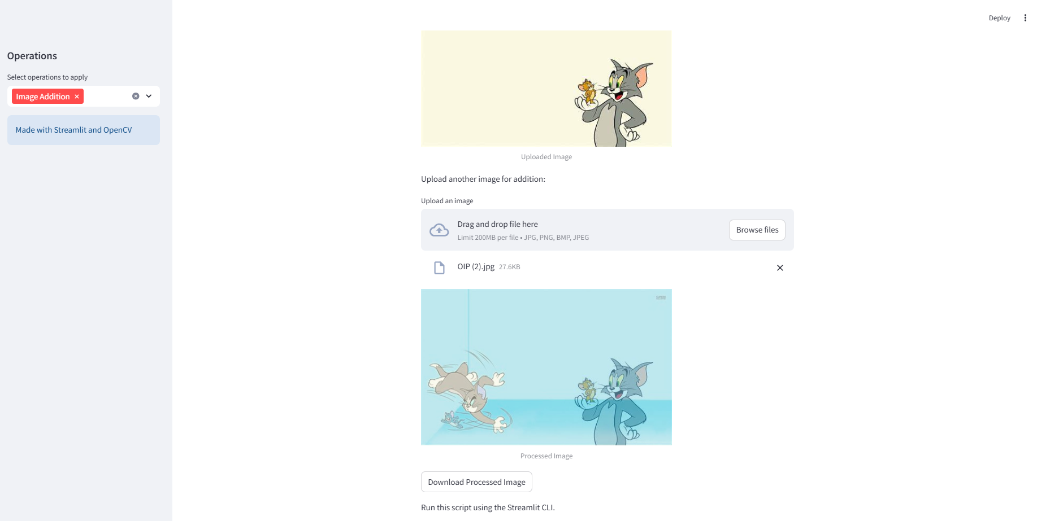

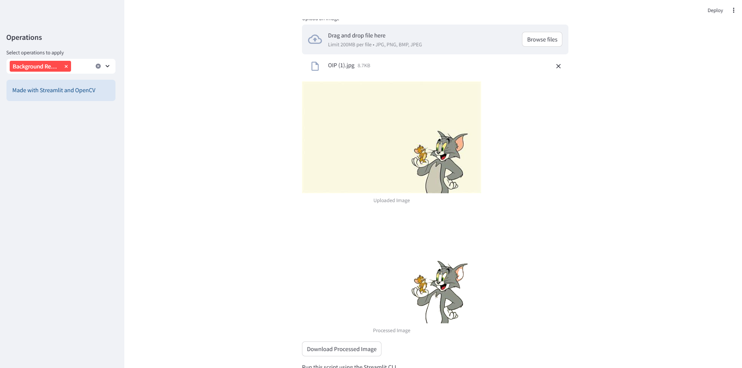

* **Background Removal:**

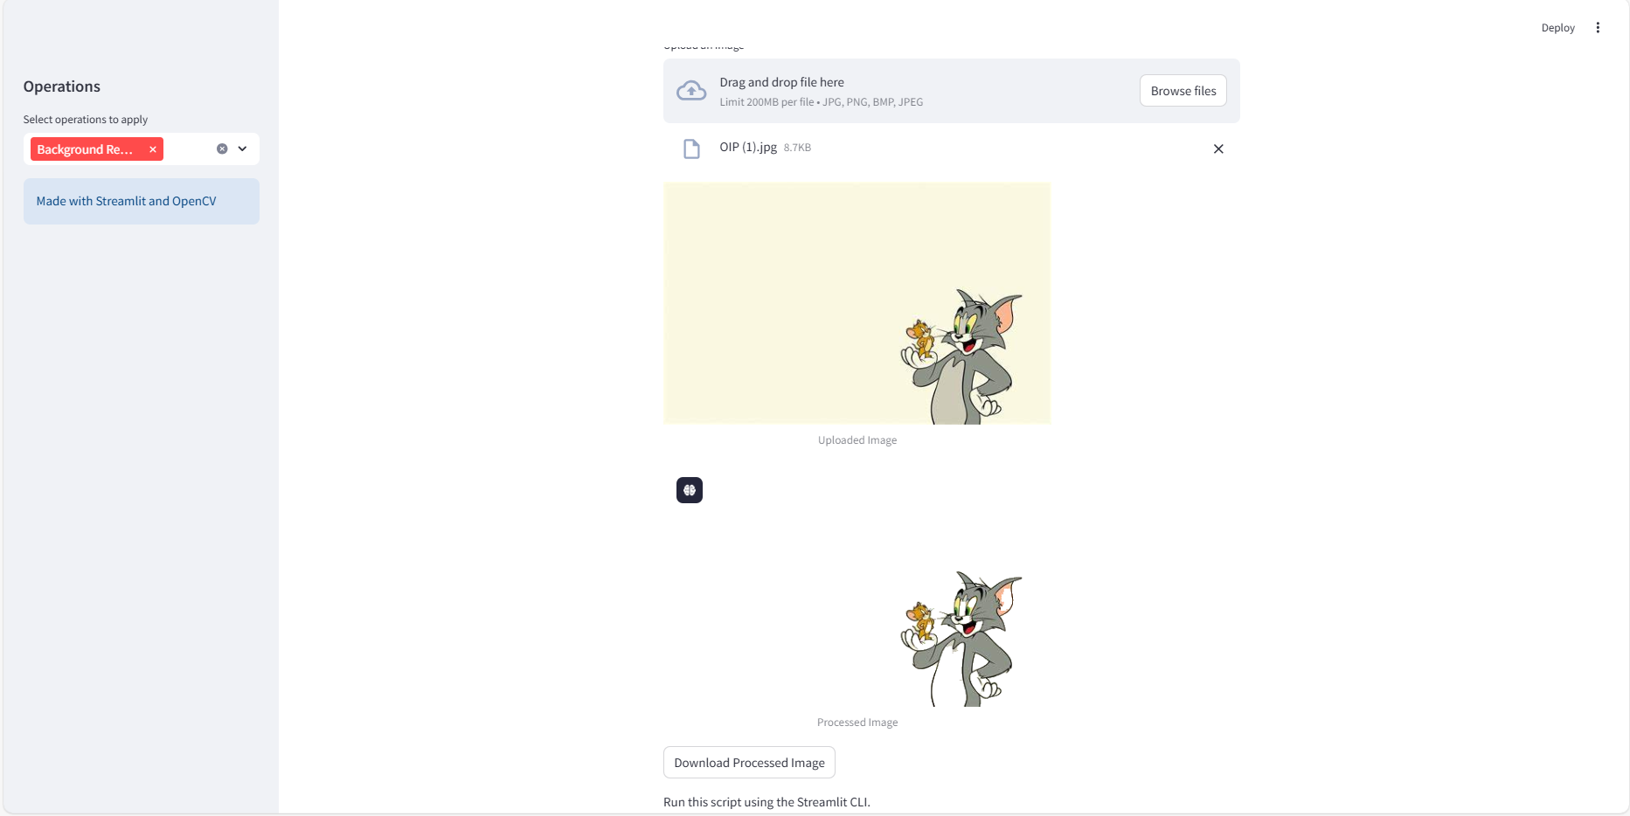

* **Image Rotation:**

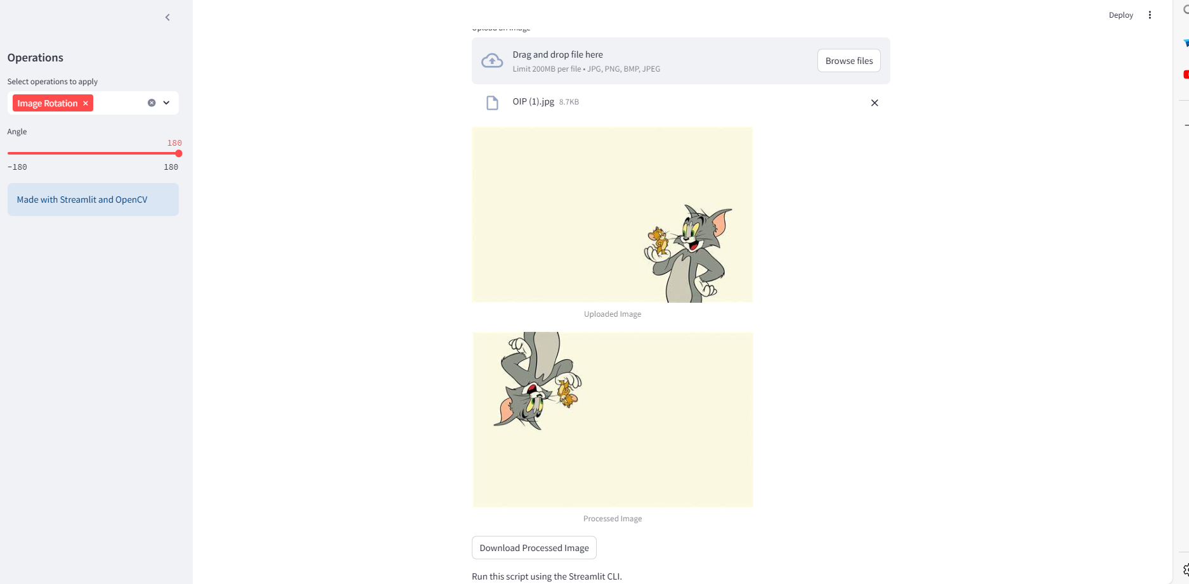

* **Image Re-sizing:**

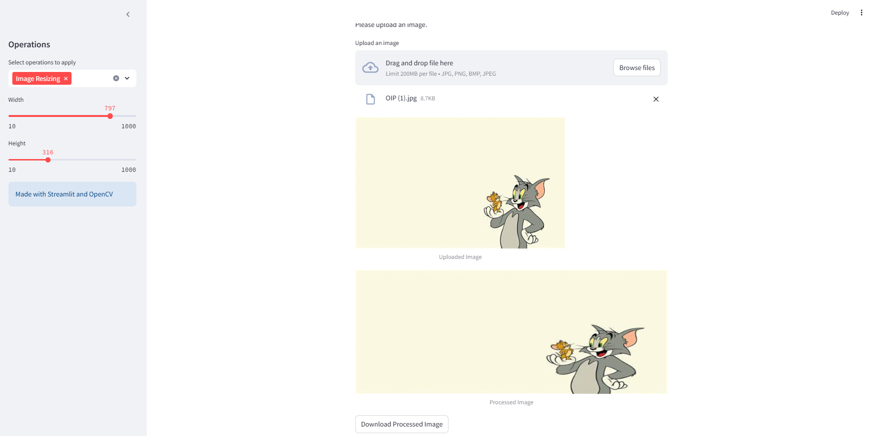

* **Image Blurring:**

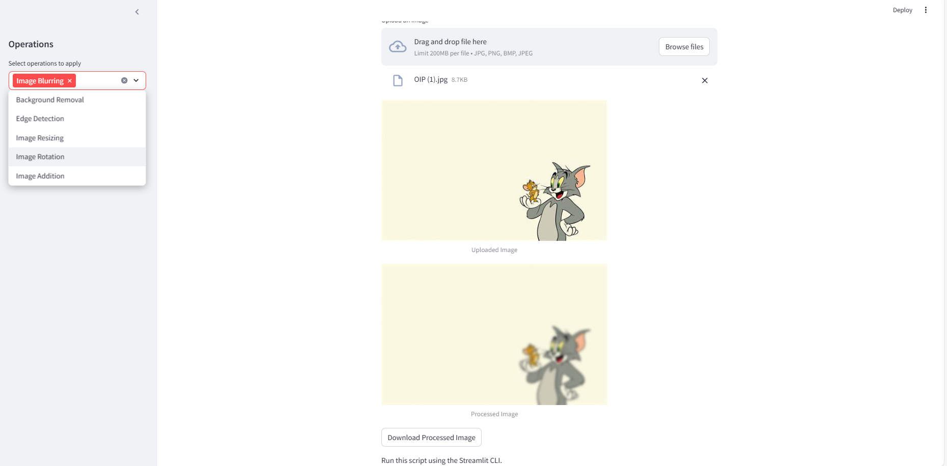

* **Edge Detection:**

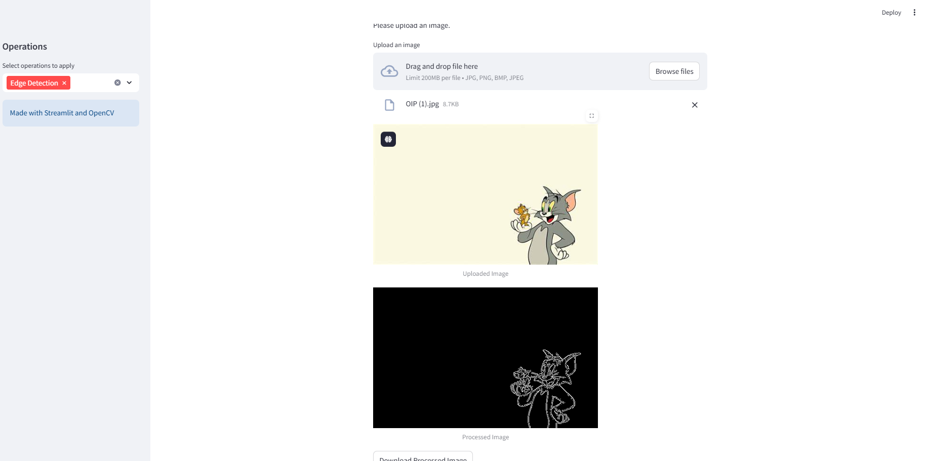

* **User can Implement all operations:**

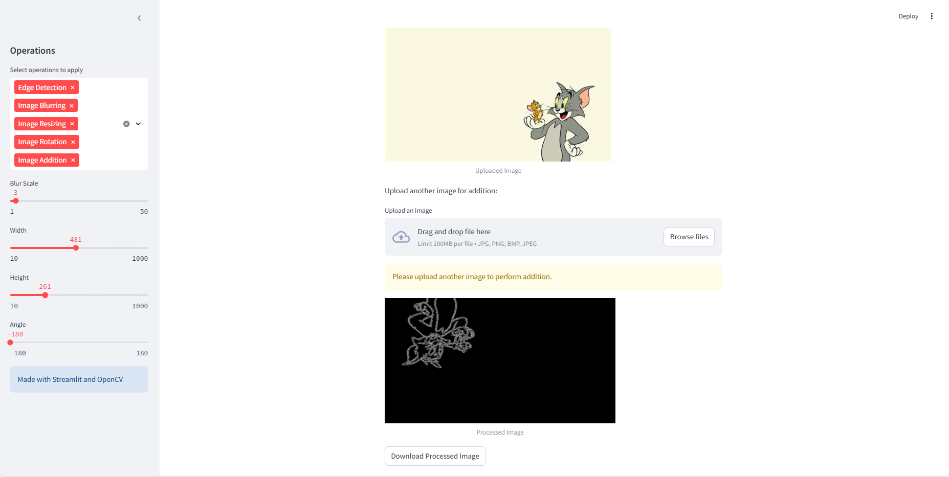

### ****References****

Bradski, G., & Kaehler, A. (2008). **Learning OpenCV: Computer Vision with the OpenCV Library**. O'Reilly Media.

NumPy Documentation. **NumPy: The fundamental package for array computing with Python**. [Online]. Available: [https://numpy.org](https://numpy.org/)

Streamlit Documentation. **Streamlit: The fastest way to build data apps**. [Online]. Available: [https://streamlit.io](https://streamlit.io/)

Pillow (PIL) Documentation. **Pillow: Python Imaging Library**. [Online]. Available: [https://pillow.readthedocs.io](https://pillow.readthedocs.io/)

OpenCV Documentation. **Open Source Computer Vision Library**. [Online]. Available: [https://opencv.org](https://opencv.org/)